My main goal was to use only two button presses to display a character similar to how well designed websites only require two clicks to get to any content. I decided to use a modified version of the two-key method. Since we had to print out, at a minimum, the alphabet (26 characters) and a space, I needed at least 6 buttons (36 possible combinations). Rather than deal with strings or search loops, I decided to hard code all the possible two-button combinations so that I only had to keep track of which buttons are pressed. After performing the set up functions, there is a delay loop at the beginning of the program that allows the serial connection to be opened up. The instructions are then displayed on the serial monitor to communicate the button combinations to the user. After a button is pressed, the button number is stored in an array then the process is repeated. Once two readings have been taken, a character is displayed depending on the combination of buttons pressed. After displaying the character, the character counter is reset as well as the button push array.

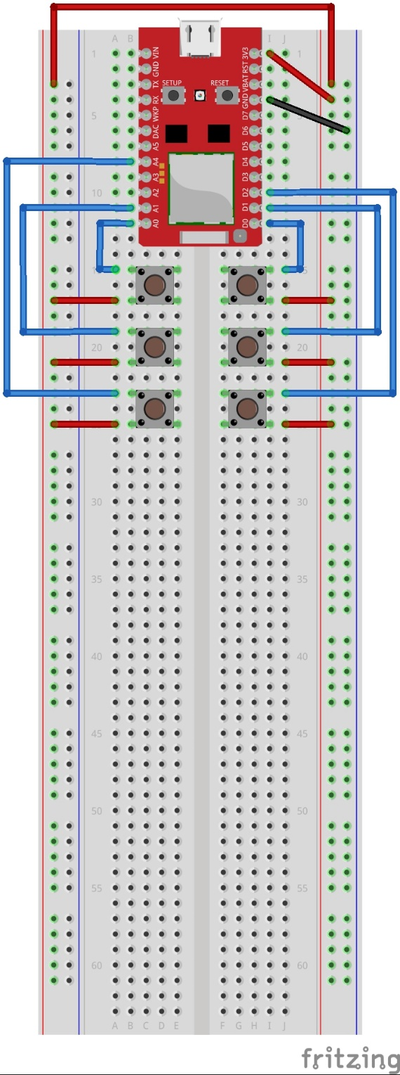

Figure 1. Redbear Duo Wiring for Duo Tap Device (using internal pulldown resistor)

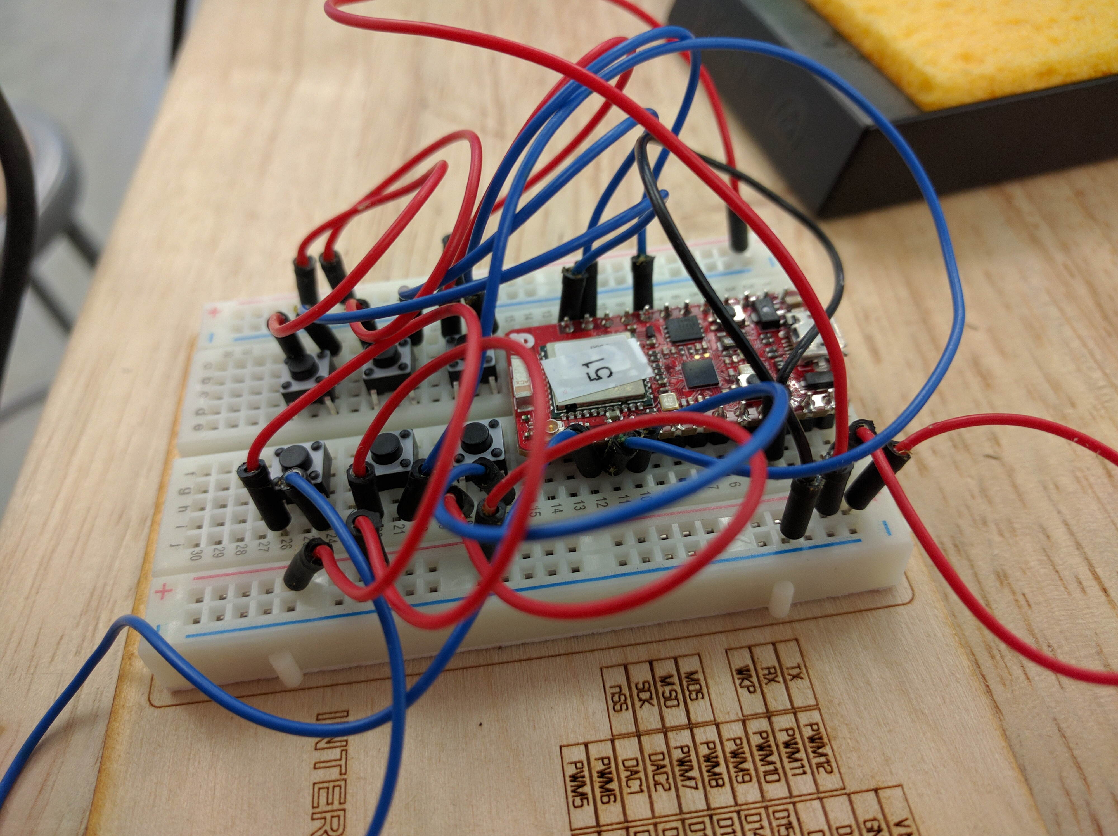

Figure 2. Six buttons wired up

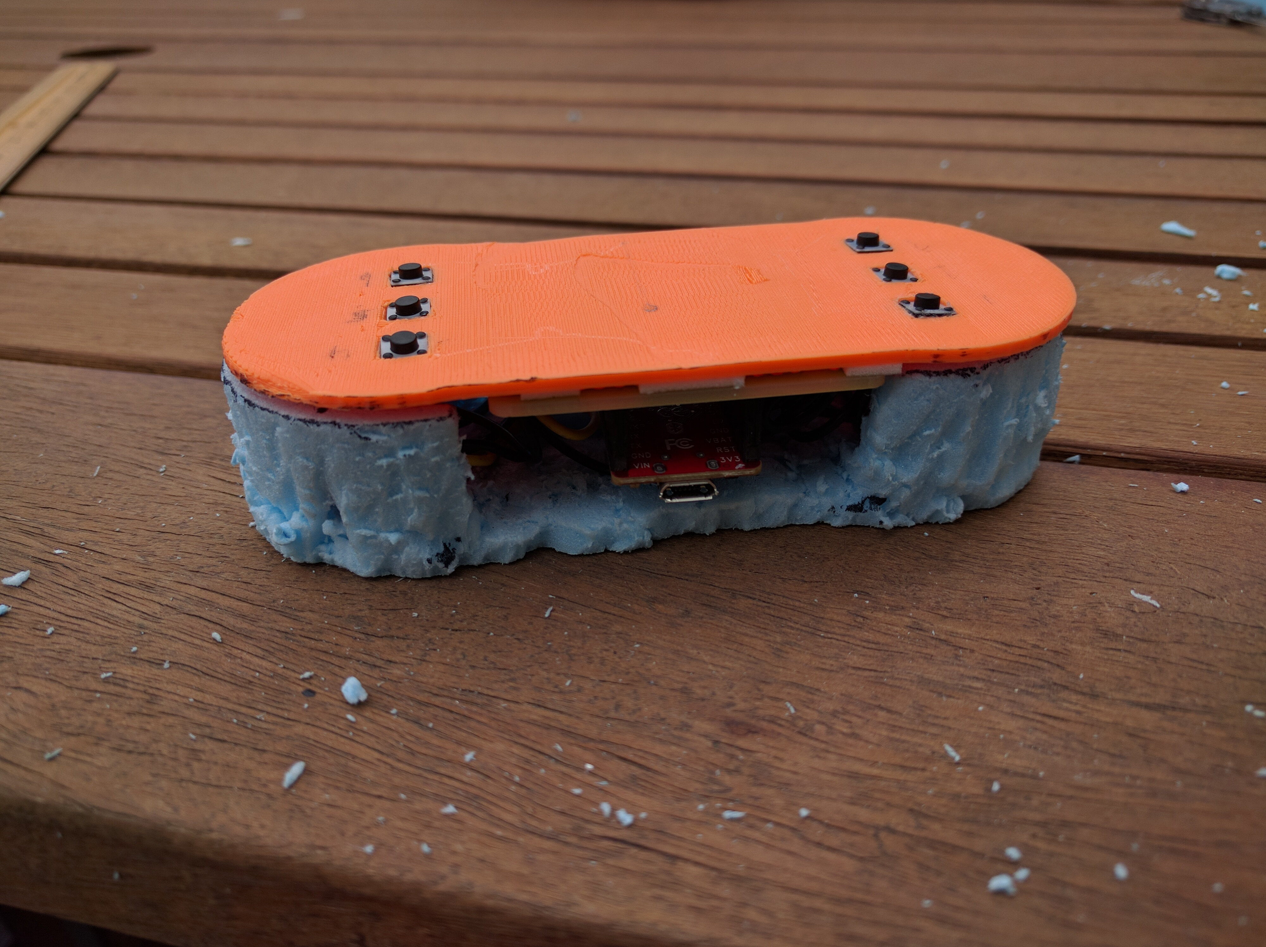

Figure 6. Improvised prototype